# NAME- Abir Chakraborty| UID- 22BCS14321 | SECTION- 601/A 1 Max Units on a Truck

bool cmp(vector<int> &a , vector<int> &b){ return a[1] > b[1];

}

class Solution { public:

int maximumUnits(vector<vector<int>>& boxTypes, int truckSize) {

sort(boxTypes.begin() , boxTypes.end() , cmp); int profit = 0;

for(int i=0 ; i < boxTypes.size() ; i++){ if(boxTypes[i][0] <= truckSize){

profit += boxTypes[i][0]*boxTypes[i][1]; truckSize -= boxTypes[i][0];

}

else{

profit += truckSize*boxTypes[i][1]; truckSize = 0;

}

if(truckSize == 0) break;

}

return profit;

}

};

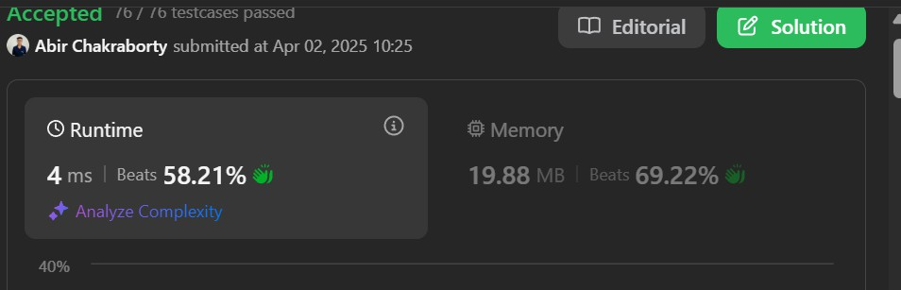

# MIN Operations to Make Array Increasing

class Solution { public:

int minOperations(vector<int>& nums) { int count=0;

for(int i=0;i<nums.size()-1;i++){ if(nums[i+1]<= nums[i]){ count+= nums[i]-nums[i+1]+1; nums[i+1]=nums[i]+1;

}

else continue;

}

return count;

}

};



# Remove Stones to Maximize Total

class Solution { public:

int minStoneSum(vector<int>& piles, int k) { priority_queue<int> maxHeap(piles.begin(), piles.end());

while (k--) {

int maxElement = maxHeap.top(); maxHeap.pop();

maxElement -= floor(maxElement / 2); maxHeap.push(maxElement);

}

int sum = 0;

while (!maxHeap.empty()) { sum += maxHeap.top(); maxHeap.pop();

}

return sum;

}

};



# Max Score from Removing Substrings

class Solution { public:

int maximumGain(string s, int x, int y) { int aCount = 0;

int bCount = 0;

int lesser = min(x, y); int result = 0;

for (char c : s) {

if (c > 'b') {

result += min(aCount, bCount) * lesser; aCount = 0;

bCount = 0;

} else if (c == 'a') {

if (x < y && bCount > 0) { bCount--;

result += y;

} else {

aCount++;

}

} else {

if (x > y && aCount > 0) { aCount--;

result += x;

} else {

bCount++;

}

}

}

result += min(aCount, bCount) * lesser; return result;

}

};



# Min Operations to Make a Subsequence

class Solution { public:

int minOperations(vector<int>& target, vector<int>& arr) { unordered_map<int, int> mapping;

int i = 0;

for (auto& num : target) mapping[num] = ++i;

vector<int> A;

for (int& num : arr)

if (mapping.find(num) != mapping.end()) A.push_back(mapping[num]);

return target.size() - lengthOfLIS(A);

}

private:

int lengthOfLIS(vector<int>& nums) { if (nums.empty()) return 0; vector<int> piles;

for(int i=0; i<nums.size(); i++) {

auto it = std::lower_bound(piles.begin(), piles.end(), nums[i]); if (it == piles.end())

piles.push_back(nums[i]); else

*it = nums[i];

}

return piles.size();

}

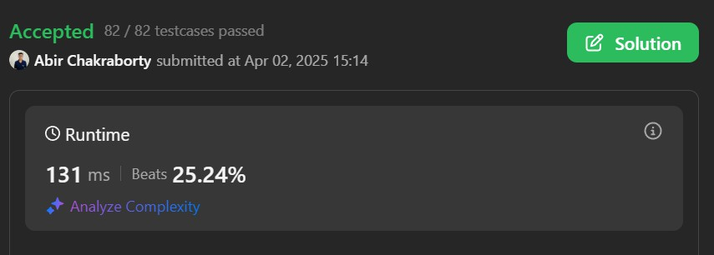};

1. **Max Number of Tasks You Can Assign**

class Solution { public:

int check(vector<int> &tasks, int take, map<int,int> count, int pills, int power) { while (take >= 1 && count.size()) {

auto it = count.end(); --it;

if (tasks[take - 1] <= it->first) {} else if (pills) {

it = count.lower_bound(tasks[take - 1] - power); if (it == count.end()) return 0;

--pills;

}

else return 0;

--take;

(it->second)--;

if (it->second == 0) count.erase(it);

}

return take == 0;

}

int maxTaskAssign(vector<int>& t, vector<int>& w, int p, int s) { int n = t.size();

int m = w.size(); sort(t.begin(), t.end()); map<int,int> Count;

for (auto &strength : w) Count[strength]++; int l = 0, r = n, ans = 0;

while (l <= r) {

int mid = l + (r - l) / 2;

int chk = check(t, mid, Count, p, s); if (chk) {

ans = mid; l = mid + 1;

}

else {

r = mid - 1;

}

}

return ans;

}

};

